[www.w3schools.com](http://www.w3schools.com)

http://www.dynamicdrive.com/

(muchos ejemplos)

<body>

<form>

<input type = "button" value "New windows"

onClick="open('http://www.yahoo.com', 'New Window',   
 'toolbar=0, location=1, menubar=1, scrollbars=1, resizable=1') ">

Open new window

<a href=”javascript:newwing(‘javascript2.html’,500,500”>Text</a>

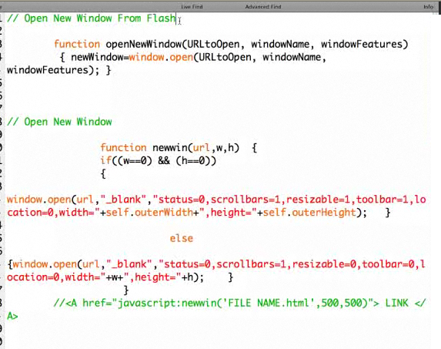

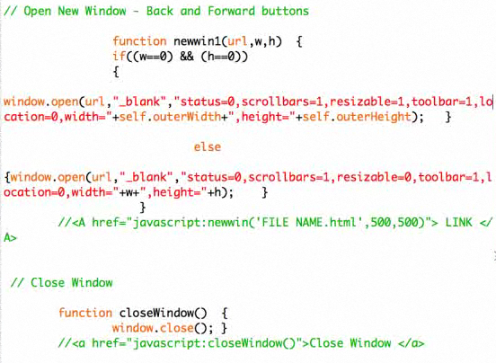

<a href=”javascript:window.close();”>Close Window</a>